**Response 1**

**Haemostasis**

This task is an extended response that addresses the topic of haemostasis (blood clotting). This type of answer needs to be reasonably detailed and informative on the topic and can be written in many forms such as:

* Diagrams with detailed notes explaining the diagram
* Tables outlining the appropriate detail – in sentence form
* A series of points that are fully explained/described in relation to the topic
* Essays written in a similar way to an English essay
* A report with headings, sub-headings,…and explanations/descriptions within

Blood clotting involves a complex series of events and reactions that occur in sequence. Describe the steps involved in the process of **haemostasis** (blood clotting) from the initial damage to tissue right through to **clot dissolution**.

In your description you will need to include:

* the types of cells involved
* the names and functions of the chemicals involved
  + thrombin, prothrombin, fibrin, fibrinogen, plasmin, plasminogen, serotonin etc.
* blood vessel responses
* clotting factors

Full marks will not be achieved if steps and/or chemicals are missing and/or out of sequence.

You must also reference the entire paper and include a bibliography.

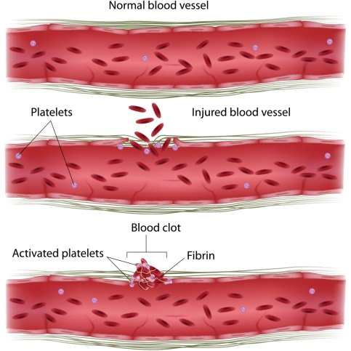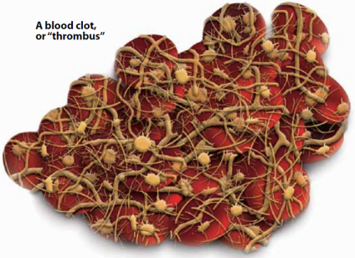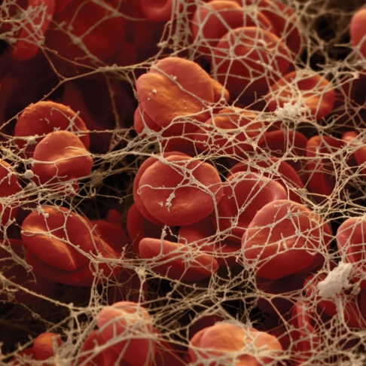This assignment is worth 10% of your Semester 1 mark.

**Guidelines**

There are 20 marks available for this assessment.

Introduction:

* Outline the reason and need for blood clotting **1 Mark**

Main Body:

* Events to be in sequence and covered in detail.
* Include from injury of tissue.
* Include each response and include names of any chemicals involved.
* Must mention:
  + Thrombocytes
  + Serotonin
  + Prothrombin
  + Fibrinogen **12 Marks**

Conclusion:

* Clot dissolution **3 Marks**

Referencing:

* In-text referencing of sources of all information **2 Marks**

Bibliography:

* Correctly constructed, alphabetical **2 Marks**

**Total 20 Marks**

**Haemostasis Assignment**

**Marking Guide**

N.B. To be awarded full marks the points mentioned must be in sequence and not leave out too much information in between points. In addition, the assignment must contain in-text referencing and have a correctly constructed bibliography.

**Blood Clotting**

* Purpose **1 mark**
* Initial damage to blood/tissue
* Types of cells involved
* Chemicals involved: thrombin, prothrombin, fibrin, fibrinogen, plasmin, plasminogen, serotonin, etc
* Blood vessel responses
* Clotting factors **12 marks**

**Clot dissolution**

Sequence of events and chemicals involved **3 marks**

**In Text Referencing**

e.g. diagrams, pictures, quotes, other’s work **3 marks**

**Bibliography** **2 marks**

**TOTAL /20**

**Haemostasis Assignment**

**Marking Guide**

N.B. To be awarded full marks the points mentioned must be in sequence and not leave out too much information in between points. In addition, the assignment must contain in-text referencing and have a correctly constructed bibliography.

**Blood Clotting**

* Purpose **1 mark**
  + causes bleeding to stop
  + prevent blood loss
* Initial damage to blood/tissue
  + blood vessel’s epithelial wall disrupted
  + first response to injury is vasoconstriction
    - reduces blood flow & blood loss
    - chemicals released by endothelial cells and platelets
    - reflexes initiated by local pain receptors
* Types of cells involved
  + **platelets** adhere (platelet adhesion) to damaged epithelium to form platelet plug (platelet aggregation)
  + platelets become spiked and stickier
  + release **ADP** – to attract more platelets
  + **serotonin** – stimulates vasoconstriction
  + **thromboxane A2** – attracts platelets, vasoconstriction and keeps platelets ‘sticky’ ( Aspirin prevents formation of thromboxane A2)
  + **clotting factors**
    - **prothrombin** is converted to thrombin
    - **thrombin** converts fibrinogen to fibrin
    - **fibrinogen** circulates in blood
    - fibrinogen converted to fibrin
    - **fibrin** forms long strands(polymer)
    - act as mesh to hold platelet plug together
    - thrombin also activates factor XIII which helps fibrin strands cohere to one another (cross-links)
    - platelets and RBCs become caught in this mesh

**12 marks**

**Clot dissolution** **3 marks**

Sequence of events and chemicals involved

* after 2/3 days, clot begins to contract
* fibrinolysis – breakdown of clot
* plasma protein plasminogen is incorporated into the clot
* new endothelial cells secrete plasminogen activator (t-PA)
* converts **plasminogen** into its active form **plasmin**
* plasmin (fibrinolysis)
* plasmin breaks down fibrin
* leads to dissolution of the clot

**In Text Referencing**

e.g. diagrams, pictures, quotes, other’s work **3 marks**

**Bibliography** **2 marks**

**TOTAL /20**